Group 4
Initial Project and Group Identification Document
Interactive Automated Chess Game
Brett Rankin, Paul Conboy, Samantha Lickteig, & Stephen Bryant
5/31/2012

Interactive Automated Chess Game
- Sponsors: Navy or self-funded
- Mentors: For the mechanical Assembly; Alan Skaggs Mechanical Engineer Walt Disney World Co. Ride and Show Engineering. Masters in Mechanical Engineering MIT.
- Project Description:
The idea is to create a portable interactive chess board where gameplay will be fully automated using a crane suspended above the chessboard that is responsible for moving all of the pieces no matter if the game is person versus computer or person versus person; any piece that is removed from play will be placed on a specified grid to the side for each player’s respective color. It will be powered by a battery and/or wall AC.
The actual board will be constructed out of Plexiglas or similar plastic material so that the inner workings can be easily viewed. Each space on the grid will be lit using LEDs to help highlight each of the possible places a player can move a specified piece. In each square on the grid, as well as the discard grids, there will be a magnet to help keep each piece centered throughout the game (helping to eliminate possible error when the claw is grabbing or placing pieces), with a corresponding magnet found in the bottom of each chess piece.
Attached on opposite ends of the board will be two displays for user input. Both will have two buttons and two input panels as well as an LCD screen; the two input panels will be FROM (what piece is being moved), and TO (where the selected piece is being moved to). The two buttons will be GO (once the FROM and TO are specified, GO finalizes the selection and the claw moves the specified piece; cannot be undone once GO is pressed) and CLEAR (to clear the player’s selection so it can be changed; can only used before GO is pressed). If the chessboard is ran in player vs. computer mode, the input panels will remain unresponsive as the AI programmed into the board will be playing the part of the second player. If we are able to implement AI we can also have a computer versus computer mode.
The crane will be suspended above the board, attached to the raised sides of the board, and will be constructed such that it will be able to move over both the X and Y axis using belts and motors as needed. Our first choice for the grabber itself will be between two to four prongs with the ends covered by either rubber tips or memory foam to grab the various different pieces securely. We might also use an electromagnet if a claw proves unreliable. The crane will be used to move all of the pieces so as to allow for the internal programming to not only keep track of the game but for a ‘coolness’ factor. Speakers installed on the side may announce various states of the game (check, checkmate, illegal move, etc.) We also plan on having an array of LEDs embedded in the board. This leaves us with many features, such as the ability to light up possible move locations for the user and the ability to light up the move selection the user is thinking.
Some of the interesting problems associated with building this project are keeping track of discarded pieces, construction of the crane system itself, programming a decently strong chess AI, and making sure our crane system is highly reliable. However, we believe the basic functionality, a robotic crane system that moves chess pieces to precise locations on a board, is well within the scope of senior design and that there is plenty of room for more features as needed.
Since Group 4 is hoping for funding from the Navy, the goal of making the game is to catch the attention of any possible recruits. Combining the LED lights, claw, and verbal status update capabilities as well as the fact that chess is one of the oldest strategy games in existence, Group 4’s design should make for an ideal eye catcher.
- Design Requirements and Specifications (DRS)
- 1-2 Microcontrollers for monitoring under board Hall Effect sensors, control under board LED lighting, motion control commands, and feedback for X-Y axis and picker controls, interfacing with the user HMIs, and for running the AI for the computer player
- At least 64 LEDs; either white or RGB
- 32 magnets for each set piece.
- 96 Hall Effect sensors; 64 for playing surface, 32 for discard zones
- 32 chess pieces with a magnet attached to the bottom
- 2-3 motor controllers (moving the claw)
- 1 LED controller or self-designed latched multiplexed LED control.
- 1 Gantry Assembly
- 1 Picker/Claw design TBD
  - Each tip covered with rubber or memory foam
  - Assuming 88-90% accuracy with each grab and placement of a single piece
- Playing surface will be covered with a defused plastic material for ideal LED lighting look. Controls will be covered with transparent Plexiglas, Lexan, or suitable similar material
- Power supply
  - 120 VAC 60 Hz input, class 2, preferably UL or equivalent NRL listed, purchased power supplies with no battery operated functionality. Output voltages TBD. If power supplies are NOT supplied with 120 VAC IEC standard cord and we need to install a circuit breaker in accordance with UL 508A standards. We will insure the power supplies are mounted inside a suitable enclosure to comply with NFPA 70E Electrical Safety Standards.
- 2 User Interface Panels (HMIs) switch arrays with a two line LED or LCD Display
- 2 Stepper motors for X-Y axis motion control.
- 1 Chess Board with 2 discard grids
  - Playing grid will likely adhere to standard dimensions (12”x12”) with each square 2/3” x 2/3” with 64 total squares in an 8x8 configuration) while each discard grid will be 1 1/3” x 12” with 16 total squares (2 x 8 configuration) Note exact dimensions TBD.
- Logic of chess AI as an added feature
- Total weight: Less than 100 lbs.
- Ideally all of our custom designed PCBs will be mounted so they are visible to the public, but still properly protected.
  - Custom PCBs to include I/O, Motor Control, possible audio control.
- Team Project Goals
Our group is comprised of four individuals, three of which are BSEE majors, and one is a CpE major. This design will give our CpE a real world experience working with hardware, and being able to write code to control a real closed loop physical system. For the team as a whole we will be interfacing with electrical, mechanical, electronics, and computer systems. Knowledge learned in a broad number of our courses will be needed specifically: Physics, Statics, Dynamics, Electronics, Embedded Systems, Digital Systems, Linear Controls, Digital Signal Processing, and Senior Design. The team wanted a project that was both achievable, and still challenging. The project functionality was clearly understandable, and easy to visualize, but presented a number of design challenge opportunities. We were able to develop design features that could be added or removed from the original concept and Design Requirements Specifications (DRS). We had no problem finding examples of automated chess boards that were based off of moving a magnet under the board to propel the various chess pieces. In fact after watching a few videos on-line, I felt like we would be just doing the same thing. By building the overhead X-Y table to pick up the pieces and even discard pieces to the side, coupled with the LED lighting effects under the board, we would have more functionality and much more of a unique final product.

- Design Considerations and Assumptions:
The automated mechanical system clearly presents the most risk and challenge. We fortunately were able to find a Mechanical Engineer mentor for guidance on this critical portion of the project. Scale of the board with respect to the scale of the chess pieces will present a very interesting mathematical problem. The answer to this problem will tell us what our tolerances are for our motion control system. We will be challenged with being able to reliably picking up pieces without disturbing the other pieces. Then we will be moving the piece to its destination, again without disturbing the other pieces. The picker must be designed with the tradeoff of being able to re-align a piece that is not optimally centered in the cell, or the optimal parking tolerance of the picker, all verses not disturbing the other pieces on the board. When a chess piece must be removed from play, and relocated to the discard zone of the board, our under board LED lights could first flash under the piece to be discarded. The picker could then relocate the discarded piece and then come back and move the piece still in play. By flashing the LED the users will understand what is taking place. The second option for this challenging scenario is to place the piece in play, right in the center of the corner of the cell of destination, and the three adjacent cells. The picker would then relocate the piece to be discarded to the discard zone. Finally the picker would have to move the piece still in play to the center of the destination cell. The first option is much more desirable from an engineering stand point.
After viewing a number of photos of chess pieces, fortunately there is no standard design for chess pieces. We will need pieces that can be reliably picked up and relocated. The Knight will require a scaled down horse head that won’t get stuck in the picker. All pieces will need a ridged surface that the picker can consistently clamp and lift. Options for acquiring optimal chess pieces for the design might be: find an optimal set of pieces to purchase, making our own, adding a common base to all of the pieces, or maybe even potting all of the pieces with a clear material with all pieces having the same outer shell size.
From a practical stand point there is a need to limit I/O and wiring to both the under board LEDs and Hall Effect sensors. If every point was hard wired we would need 256 plus the DC common buss. 257 wires quickly becomes a massive wire harness. The solution will be to build a multiplexed grid under the board. Each row will have its own RGB buss and each column will have its own column select buss. A similar arrangement will be deployed for the Hall Effect matrix.
Each of the two HMIs will have a small two line LCD display. With the displays, the multi-color RGB LEDs, and the Hall Effect sensors all in use, error detection will be possible. Our worst case failure mode is if the automated picker fails to move a piece from its source to its destination. With our design we can detect the fault and communicate it to the users. The users could reposition the piece at the correct location, and the game could continue to be played.
Our versatile concept lends itself well to additional features either being added or removed from the final product. For example an automated reset feature could be added, where all of the pieces in the discard zone, or relocated pieces on the playing surface can be automatically moved back to the start configuration. This feature simply becomes software and testing add on. The LEDs could give the player hints on possible user moves, again it comes down to programing and testing.
- Block Diagram:
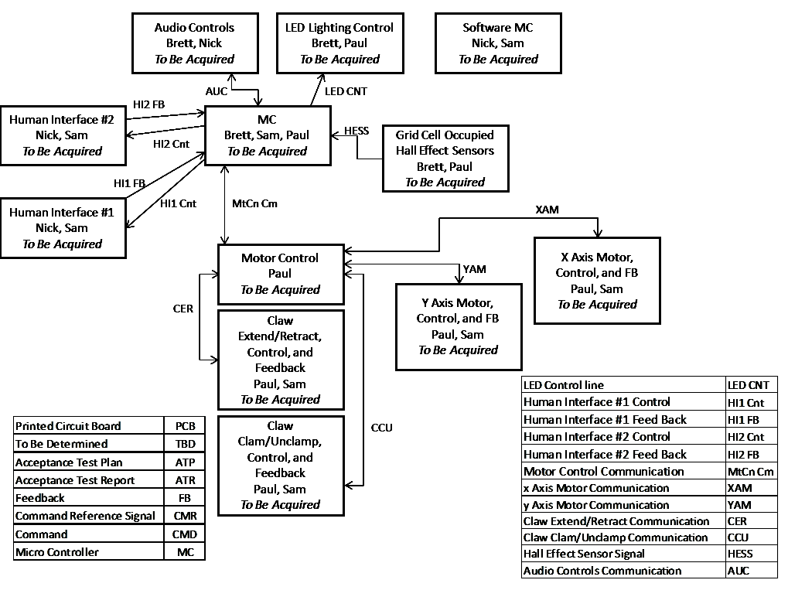

- I/O List Gaming Control
Digital Inputs:
8 Hall Effect Sensor inputs 96 multiplexed in to 8 inputs
40 User input switches possibility of multiplexing input switches
6 Gantry Hall Effect, Proximity, Thru Beam, or limit switch inputs
Digital Outputs:
24 RGB LED logic outputs
4 Hall Effect select outputs
3 RGB LED common select outputs
8 Motion Commands (source destination data, and motion enable)
RS-232 Outputs:
2 ports one for each two line display
- Features and Functions
Three gaming modes, Machine Vs. Machine, Machine Vs. Player, Player Vs. Machine.
Error checking for automation. In the event the machine fails to properly relocate the piece, the LEDs and two line displays can prompt the user to move the piece to the correct destination, and then clear the fault to resume game play.
Pre-recorded audio effects
Automatic Machine game reset after game end. The machine will move all pieces in the discard zones back to the appropriate starting places.
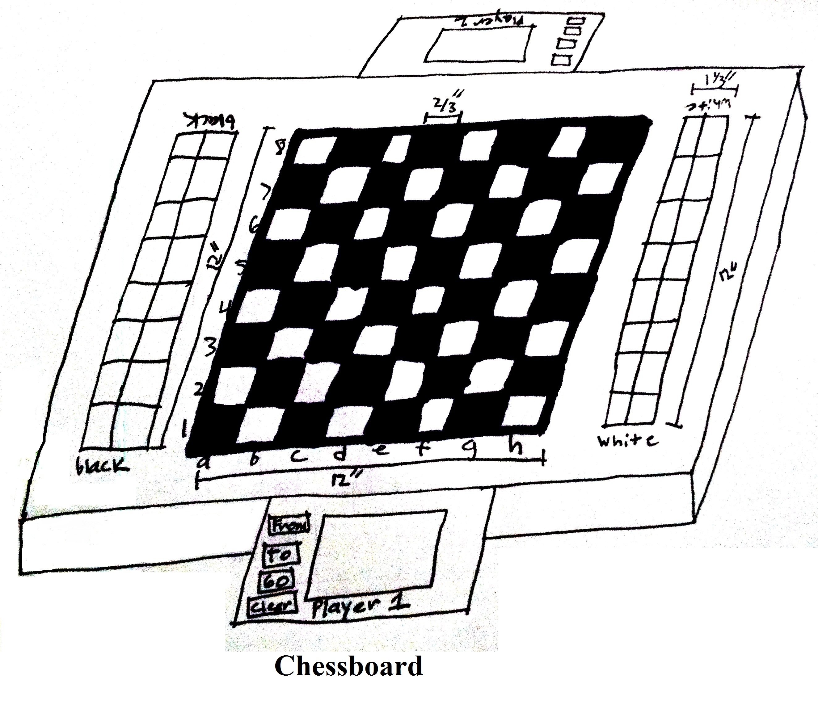
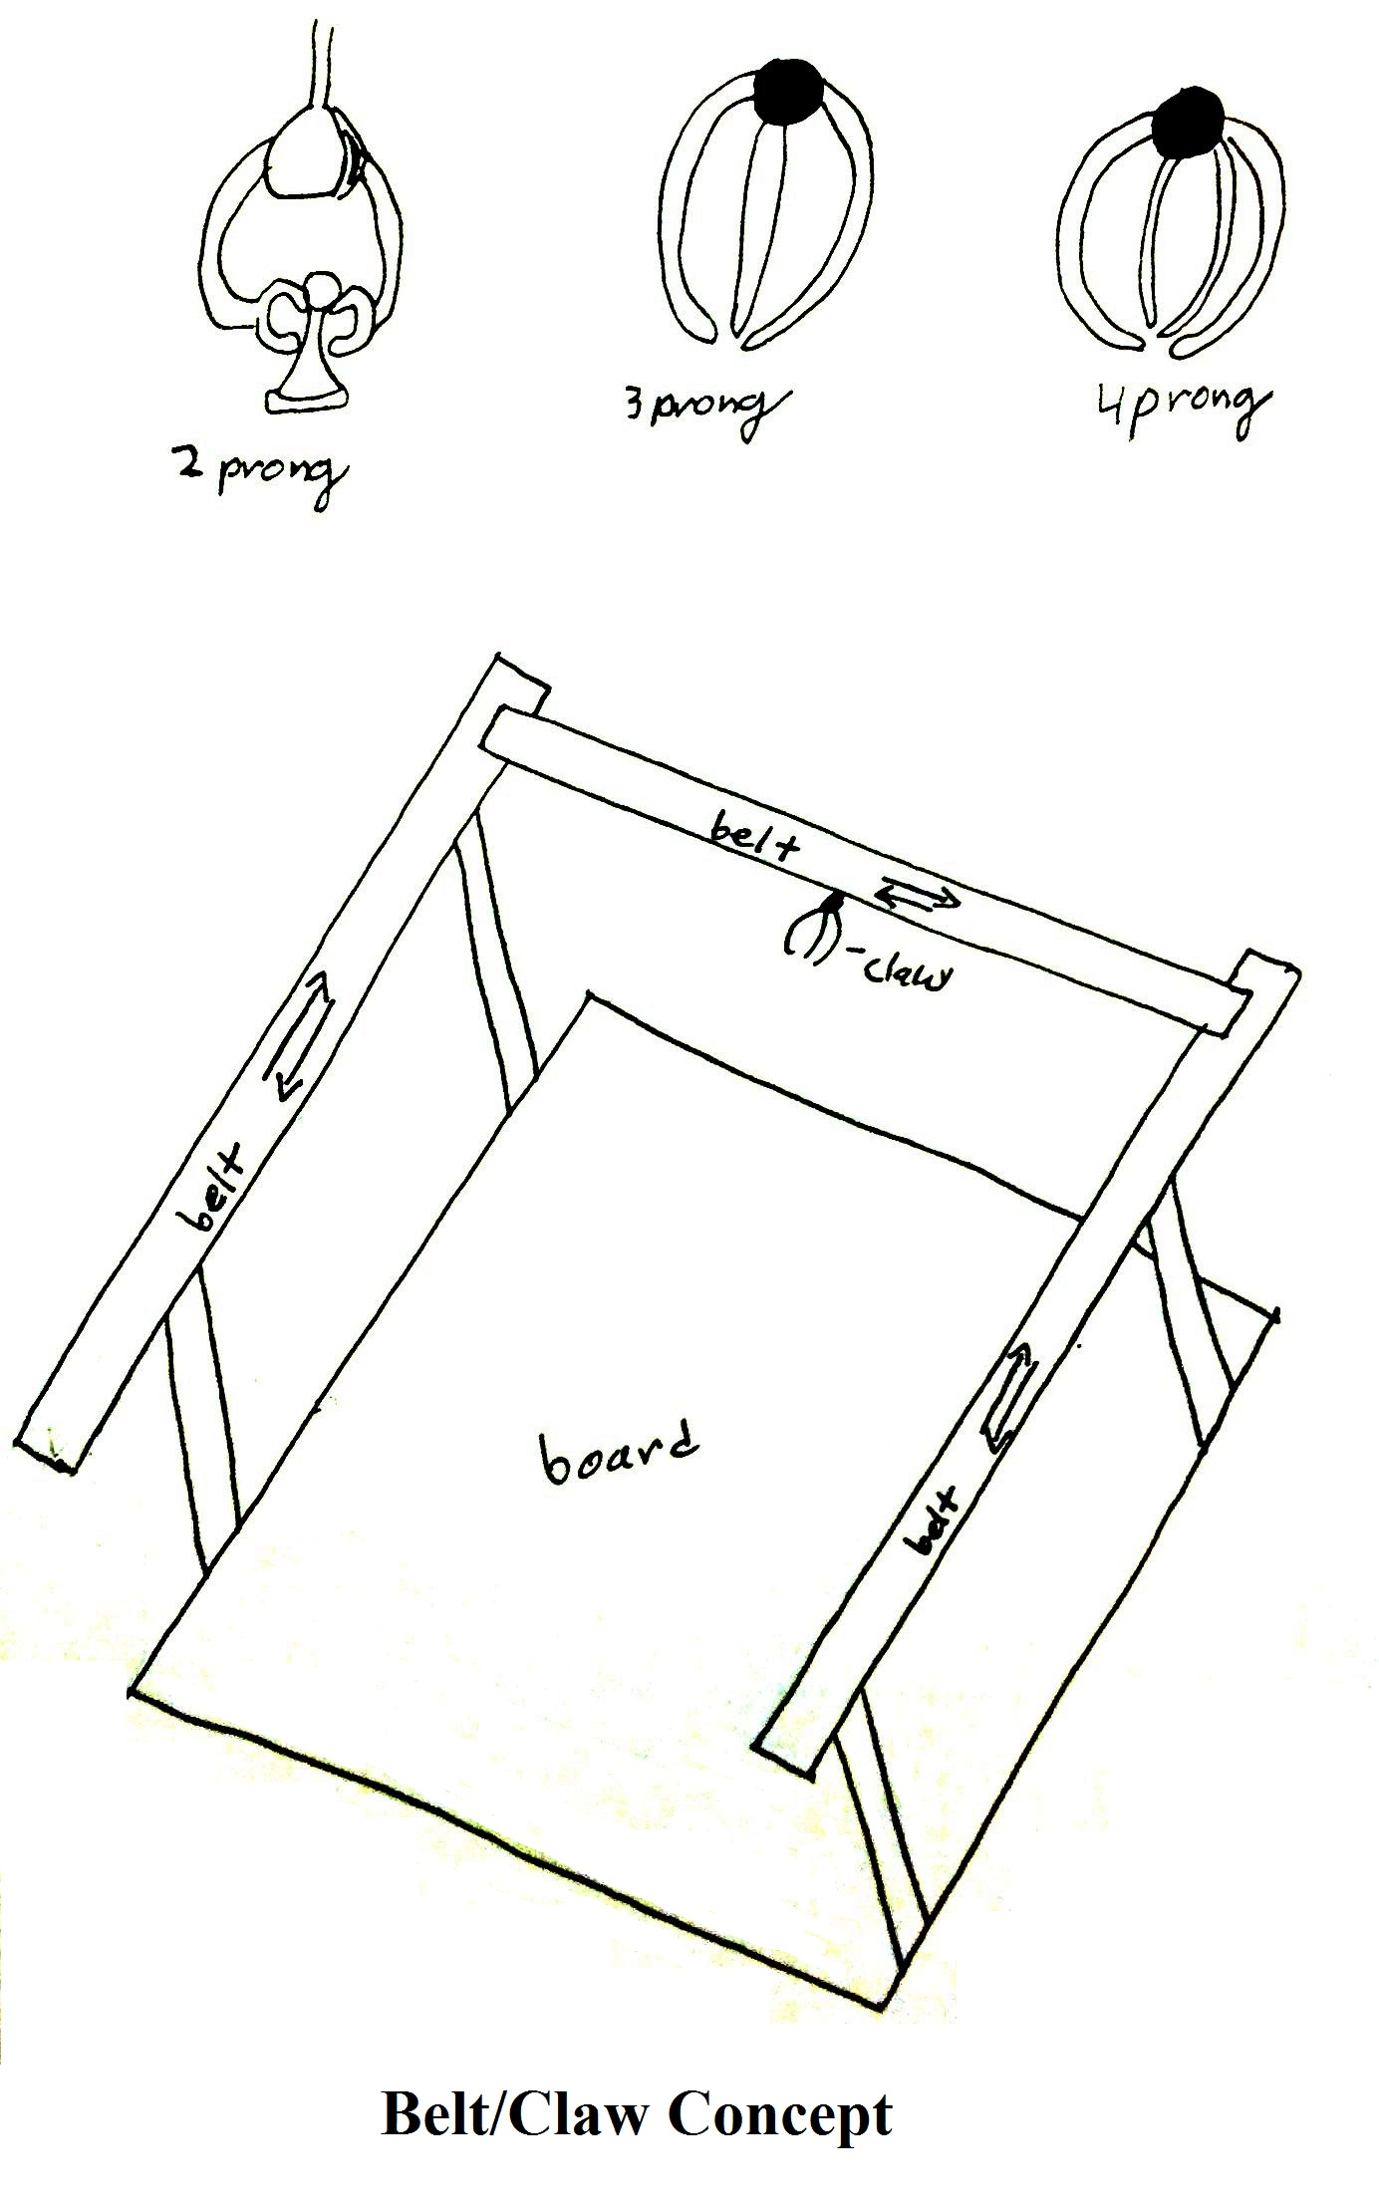
- Budget
Budget and Financing: Under $1000
Project Milestones:
- Approval/Funding Process: 1 Week
- Planning/Assignment of responsibilities: 1 Day
- Initial Project and Group Identification Document: 2 Weeks
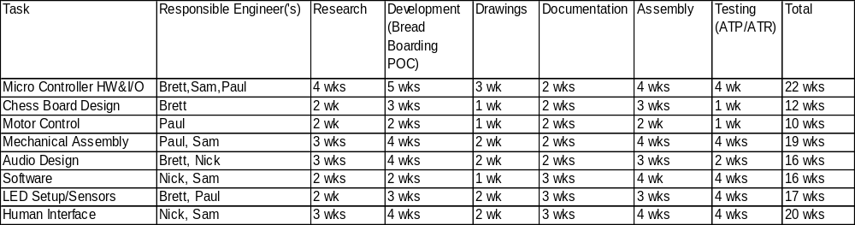
11. Abbreviations and Acronyms
